TOWN OF GROTON
Office of the Commissioners of Trust Funds
173 Main Street, Groton, Massachusetts 01450
Karen F. Tuomi, Executive Director
trustfunds@grotonma.gov
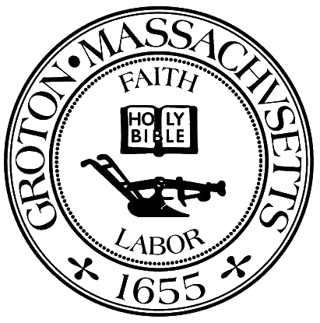

Commissioners of Trust Funds Meeting Minutes
November 15, 2023 Noon
Town Hall 1st Floor Meeting Room

Attendees: Martha McLure, Joe Twomey
Guests: Mark Gerath, Vanessa Abraham, David Zeiler
Review bills for approval and signatures
Meet with Library Trustees – meeting with “suits” on January 9, 2024 at 11am.
The Trustees are here to discuss the new Fiscal year 25 allotment and to ask for additional funds. They are asking for $75k for FY25. In the future they are considering a renovation to the Childrens Room. They wanted to give a heads up about future considerations. Commissioners made a motion to approve the $75k for FY25 and the Trustees said they would leave it up to the Commissioners which fund to take it from. Seconded and voted unanimously.
Meeting with Financial Advisors – January 9, 2024
GDRMS – 8th Grade Washington DC Trip – funds not available
GDRHS – Senior Class Trip – funds not available
World of Difference Additional Request – TBD
GPD Lecture Fund Request – not received
Prescott Lecture Fund - withdrawn

Director’s Report:
Social Media Update – Facebook page, Instagram, QR Code, Way Back Wednesdays, etc.
Loaves and Fishes - Attended a meeting on October 30th. The Commissioners are not listed in the Newsletter but are in the Annual Report as Town of Groton. This should be changed in the future to be Commissioners of Trust Funds – Town of Groton
December holidays update:
Confirming age eligibility – Up to Middle School – no High School (HS eligible for Drivers Ed depending on fund availability – depending on availabilty
GELD Bill
School Nurses
Set Up Legion Hall on December 2nd
Open session for topics not anticipated 48 hours prior to the meeting
A vote to enter into Executive Session was not taken.
Discuss Charity Application (0)

