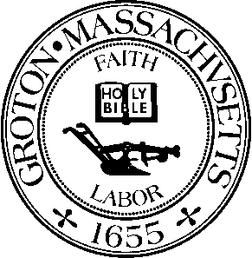
TOWN OF GROTON
Board of Health
173 Main Street
Groton, MA 01450

BOARD OF HEALTH
Robert J. Fleischer, Chairman
Michelle Collette, Member

Date: Monday, September 20th, 2021
Time: 7:00 PM
Location: 1st Floor Meeting Room, Groton Town Hall
Members Present: Robert J. Fleischer, Chairman; Michelle Collette, Member

Robert Fleischer called the meeting to order at 7:04 p.m.

OLD / NEW BUSINESS

MEETING MINUTES

The Board reviewed the meeting minutes dated May 17th, 2021.

Michelle Collette noted the following corrections:

- Jason Weber was still the Chairperson at the Board of Health meeting on May 17th, 2021.
- The discussion of the finished basement space at 101 Cherry Tree Lane was a meeting and not a hearing.
Both of these corrections will be made.

Michelle Collette moved to accept the meeting minutes dated May 17th, 2021 as amended. Robert Fleischer seconded and the motion carried.

INVOICES

Board members reviewed and signed the following invoice(s):

- Nashoba Associated Boards of Health $10,983.32 Date of Invoice: 9/1/2021
- Verizon $102.98 Date of Invoice: 8/22/2021

The Board members moved to recess the meeting at 7:08 p.m. to join the Select Board members upstairs for their joint session to interview candidates to fill the Board of Health member vacancy.

Candidate Dr. Evan Thackaberry was the newly selected member to the Board of Health.

Minutes by Sammie Kul.

APPROVED: October 4, 2021

